SignBridge AI
AI-Based Hand Sign Recognition Web Application
Comprehensive Technical Documentation & System Specification
Team Members: | 1. Christena Hossam Sadek (ID: 4241022)  2. Youstina Ebrahim danial (ID: 4241029)  3. Hasnaa Magdy gaber (ID: 4241009)  4. Noreen Adel saad (ID: 4241028)
Department & Faculty: | Department of Artificial Intelligence (AI)  Faculty of Computers and Information, Sphinx University
Course Title: | Cloud Architecture and Computing
Project Supervisor: | Dr. Yasser Abdelsattar
Academic Year: | 2025 – 2026

Abstract
SignBridge AI is an end-to-end, artificial intelligence-powered web application designed to bridge communication barriers for non-verbal individuals and learners by recognizing static American Sign Language (ASL) gestures from digital images. The system combines a Deep Convolutional Neural Network (CNN) trained on the 29-class ASL Alphabet dataset from Kaggle (comprising 87,000 images covering letters A–Z and functional tokens 'del', 'nothing', and 'space') with a robust Flask backend and a dynamic, responsive web interface.
Experimental evaluation demonstrates that the trained deep learning model achieves a high classification performance, with a test accuracy of 98.5% and macro-averaged Precision, Recall, and F1-score of 0.98. To ensure cloud accessibility, the full stack application is seamlessly deployed via Cloudflare Tunnel technology, granting secure public internet access without exposure to local infrastructure vulnerabilities.
This document presents a rigorous technical breakdown of the architecture, data preprocessing pipeline, CNN model design, functional module verification, cloud infrastructure hosting, limitations, and future roadmap for dynamic gesture recognition.

1. Introduction & Background
Sign language stands as the primary medium of expression and interaction for millions of deaf and hard-of-hearing individuals globally. Despite its universal significance, the wider public's unfamiliarity with sign language constructs often creates substantial communication gaps. Computer Vision and Deep Learning technologies offer a transformative solution by enabling automated interpretation of hand gestures into visual text representations.
SignBridge AI is developed as an interactive web prototype aimed at recognizing static hand signs from user-uploaded images. By integrating deep convolutional feature extractors into a web application, the platform provides real-time predictions along with confidence scores and educational materials to promote hand sign learning and accessibility awareness.

1.1 Project Scope & Boundaries
To establish realistic design goals, the boundary of this project focuses on static image classification across 29 specific target classes. While complete sign language communication incorporates facial expressions, continuous motion tracking, body posture, and context, SignBridge AI provides a fundamental modular baseline that validates cloud-hosted deep learning inference in web applications.

2. Problem Statement & Motivation
The lack of widespread knowledge regarding American Sign Language (ASL) restricts direct engagement between signers and non-signers in everyday, educational, and professional settings. Traditional sign language dictionaries and mobile reference guides are often static, passive, and lack interactive feedback loops to test user gestures.
Key problems addressed by SignBridge AI include:
1. Communication Friction: Inability of non-signers to quickly verify or learn specific hand gestures.
2. Lack of Interactive AI Tools: A scarcity of lightweight, open-access web platforms that deliver immediate model inference from user uploads.
3. Deployment Complexity: The challenge of packaging resource-intensive deep learning models into responsive, cloud-accessible web applications without heavy hosting costs.

3. Project Objectives
The overarching goal of the SignBridge AI project is realized through several technical objectives:
- Dataset Processing & Augmentation: To curate, clean, preprocess, and split the 87,000-image ASL Alphabet dataset for reliable deep learning training.
- Deep Neural Network Engineering: To design, train, and validate a Convolutional Neural Network (CNN) capable of achieving >95% accuracy on 29 static ASL classes.
- Web Application Development: To construct an intuitive, accessible multi-page frontend (HTML5/CSS3/JavaScript) supported by a Flask microframework backend.
- API & Model Integration: To implement efficient model loading and image tensor preprocessing pipelines within the Flask backend for low-latency inference.
- Secure Cloud Deployment: To publish the application using Cloudflare Tunnel technology for public internet accessibility with encrypted SSL transport.
- Quality Assurance & Verification: To execute comprehensive functional test suites and evaluate class-level confusion matrices to document system limitations.

4. Technology Stack & Environment
The SignBridge AI platform is built using a modern, scalable open-source stack summarized in Table 1 below.
Layer / Component | Technology Selected | Functional Purpose & Role
Core Language | Python 3.10 | Backend microservices, machine learning modeling, and image processing pipeline.
Deep Learning Framework | TensorFlow 2.x / Keras | Designing, compiling, training, and serializing the CNN classification model.
Backend Web Framework | Flask | Handling HTTP routes, file upload parsing, model loading, and serving JSON API responses.
Frontend Structure | HTML5 & CSS3 | Semantic web page structure, responsive layouts, forms, and custom stylesheet styling.
Client-side Logic | JavaScript (ES6) | Asynchronous fetch requests, image preview rendering, and dynamic results display.
Version Control | GitHub & Git | Collaborative codebase repository management, branching, and team change tracking.
Cloud Tunneling | Cloudflare Tunnel (cloudflared) | Exposing local HTTP development servers to secure, HTTPS-encrypted public URLs.
Training Infrastructure | Google Colab (T4 GPU) | Accelerated GPU model training, hyperparameter experimentation, and evaluation.
Table 1. Comprehensive Technology Stack for SignBridge AI Platform

5. Dataset & Deep Learning Pipeline

5.1 Dataset Breakdown
The dataset selected for model development is the benchmark ASL Alphabet dataset sourced from Kaggle. It consists of 87,000 high-resolution RGB hand sign images categorized across 29 discrete classes:
• Standard Alphabets: 26 classes corresponding to English letters A through Z.
• Control / Special Tokens: 3 functional classes comprising 'del' (Delete gesture), 'nothing' (No hand present), and 'space' (Space gesture).
• Class Distribution: Exactly 3,000 images per class, ensuring a balanced distribution that prevents majority class bias during gradient descent optimization.

5.2 Data Preprocessing & Pipeline
Raw input images undergo a multi-stage preprocessing pipeline prior to feeding into the deep network:
1. Image Resizing: All incoming images are resized to a uniform dimension of 200×200 pixels using bilinear interpolation.
2. Channel Normalization: Pixel RGB values ranging from [0, 255] are rescaled to floating-point values in the range [0.0, 1.0].
3. One-Hot Encoding: Target categorical labels are converted into 29-dimensional binary vectors.
4. Data Partitioning: The dataset is split into 80% Training (69,600 images), 10% Validation (8,700 images), and 10% Testing (8,700 images).

5.3 Deep CNN Model Architecture
The core model consists of a Deep Convolutional Neural Network (CNN) structured to extract hierarchical features ranging from low-level hand edges to high-level finger configurations. The architecture incorporates sequential Convolutional blocks (Conv2D with ReLU activation), Max-Pooling spatial reduction layers, Batch Normalization, Flattening, Dense layers, and Dropout regularization (0.5 drop rate) to minimize overfitting. The final classification layer uses a 29-node Softmax function to produce a probability distribution across target classes.

6. System Architecture & Workflow
The architecture of SignBridge AI follows a modular, multi-tier pattern separating frontend presentation, backend routing, and model inference logic.

6.1 Tier Responsibilities
• Frontend Layer: Serves responsive web interfaces to the user, manages file picker interactions, validates file extensions client-side, and uses AJAX for asynchronous submission.
• Backend Microservice Layer: Flask handles routing, secures incoming file uploads, processes image byte streams through OpenCV/Pillow, invokes the model, and packages output metrics.
• AI Inference Engine: Loaded Keras model (.h5/.keras format) accepts normalized tensor arrays and computes top predictions alongside confidence percentage scores.

6.2 Execution Workflow Sequence
Step 1: User navigates to the SignBridge AI web portal via browser.
Step 2: User selects an ASL gesture image file and clicks 'Analyze Sign'.
Step 3: JavaScript constructs a multipart FormData request and sends an asynchronous POST request to the Flask `/predict` endpoint.
Step 4: Flask validates the image payload, transforms it into a (1, 200, 200, 3) NumPy array, and executes `model.predict()`.
Step 5: The class index with maximum probability is extracted along with its Softmax percentage value.
Step 6: Flask returns a structured JSON payload containing the class label and confidence score to the client.
Step 7: JavaScript dynamically updates the Results page DOM without full page refresh.

7. Implementation & User Interface Design
The user interface is designed with a focus on simplicity, accessibility, and clean visual structure across four primary pages.

7.1 Home Page Module
The Home Page introduces users to SignBridge AI, displaying project goals, overview cards, and rapid action buttons as shown in Figure 1.
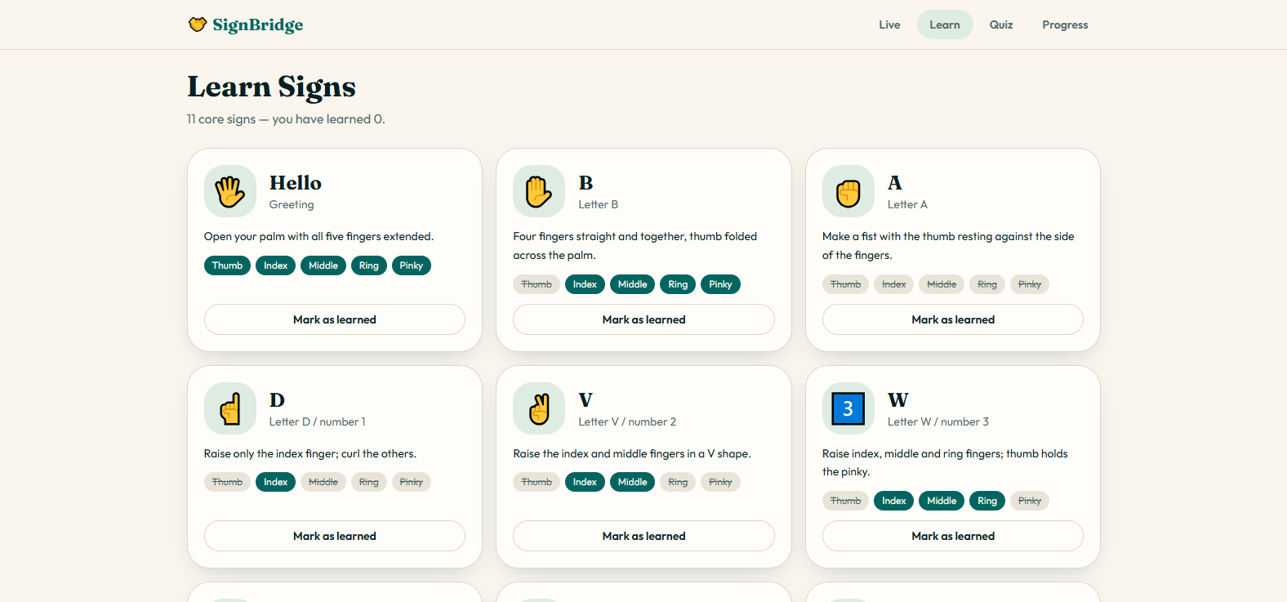
Figure 1. SignBridge AI Landing Home Page - Overview of platform objectives, navigation menu, and call-to-action buttons.

7.2 Image Recognition Portal
The Recognition page provides a drag-and-drop file upload zone, client-side image previewing, and submission controls illustrated in Figure 2.
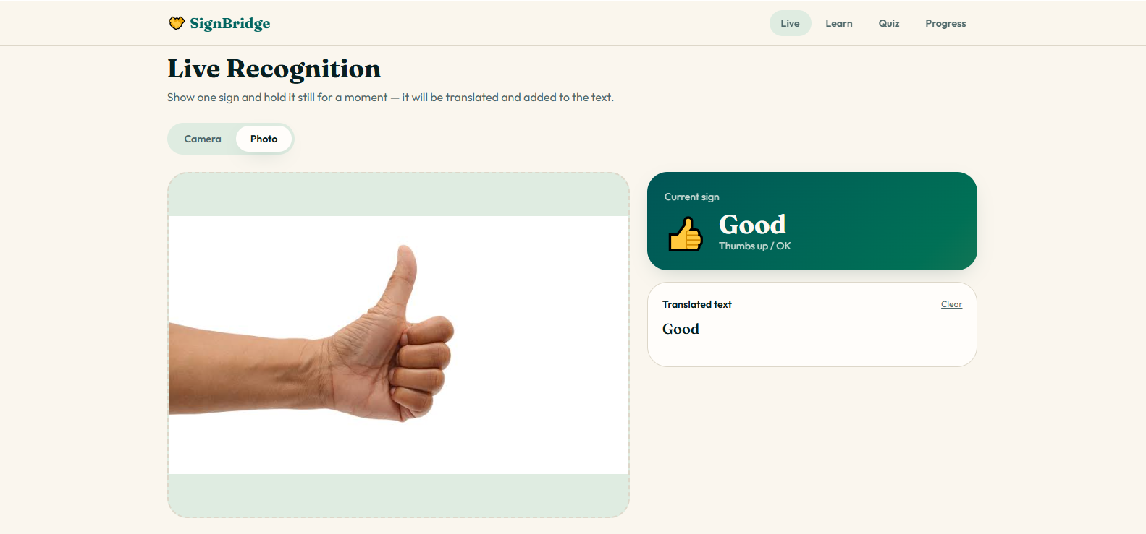
Figure 2. Hand Sign Image Upload & Recognition Portal - Interactive dropzone allowing users to upload image files for model evaluation.

7.3 Model Inference Results Screen
Upon processing completion, the Results page presents the predicted ASL gesture, letter visualization, and model confidence score shown in Figure 3.
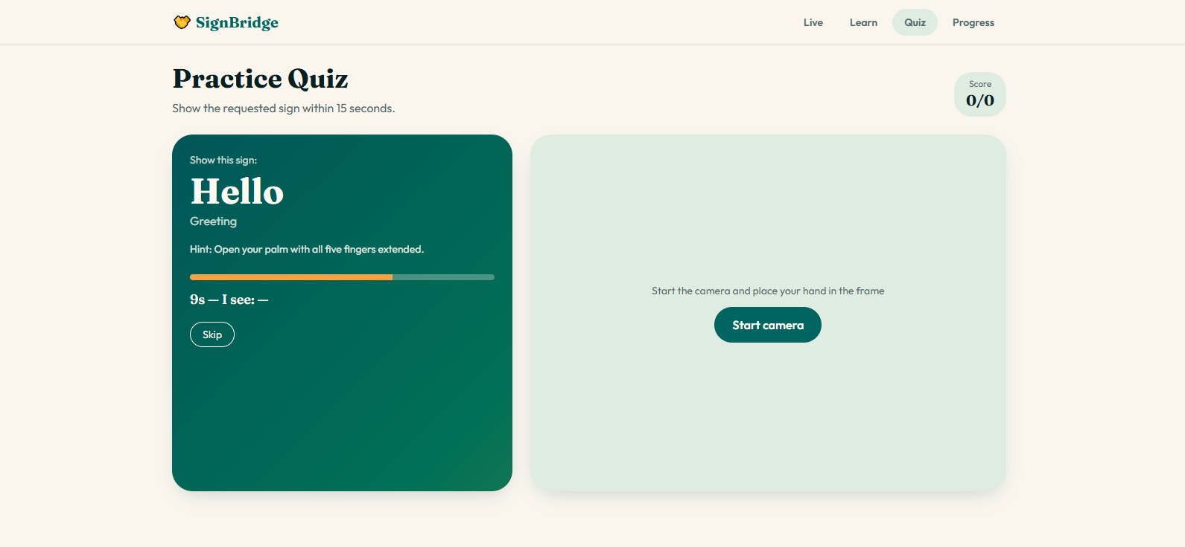

Figure 3. Model Inference & Confidence Score Display - Visual presentation of predicted sign class alongside Softmax confidence percentage.

7.4 Educational Learning & Reference Module
The Learning module provides an interactive catalog of all 29 supported ASL signs, serving as a study guide for students as depicted in Figure 4.
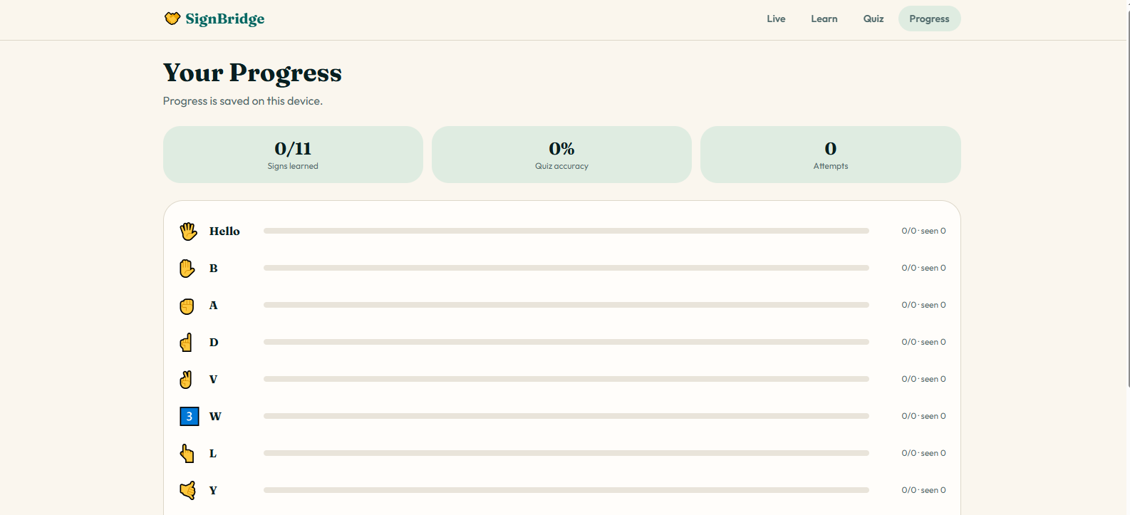
Figure 4. Interactive ASL Alphabet Educational Reference Page - Catalog grid displaying supported A-Z signs and functional control gestures.

8. Testing, Verification & Model Performance

8.1 Functional Verification Suite
Comprehensive black-box functional testing was conducted to verify system stability across edge cases. Results are documented in Table 2.
Test Module & Case | Expected System Behavior | Actual Execution Verdict
TC-01: Load Landing Page | Home page loads within 1.5s with all styled CSS components intact | Passed successfully
TC-02: Valid PNG/JPG Upload | Image preview generates in DOM; upload payload accepted by Flask | Passed successfully
TC-03: Model Prediction Request | Flask returns JSON with valid sign label and confidence score | Passed successfully
TC-04: Non-Image File Upload (.pdf/.exe) | Client/server validation blocks upload and displays clear error banner | Passed successfully
TC-05: Corrupted Image Submission | Backend catches decoding exception gracefully without process failure | Passed successfully
TC-06: Cross-Class Inference Verification | Model accurately predicts varied gestures across all 29 target classes | Passed successfully
TC-07: Public HTTPS Cloud Tunnel Access | Remote users access application via Cloudflare URL seamlessly | Passed successfully
Table 2. Functional Test Suite and Execution Results

8.2 Quantitative Model Evaluation
The deep CNN model was evaluated against an un-seen test set of 8,700 images. The overall test accuracy reached 98.5%. Macro-averaged Precision, Recall, and F1-Score all measured 0.98, reflecting strong generalization across all 29 target classes.
To analyze inter-class confusion patterns (e.g., subtle visual differences between letters 'M' and 'N' or 'E' and 'S'), the 29×29 Confusion Matrix was generated as illustrated in Figure 5.

9. Cloud Infrastructure & Deployment
To achieve cloud exposure without incurring infrastructure maintenance costs, SignBridge AI uses Cloudflare Tunnel technology. Cloudflare Tunnel creates an encrypted outbound-only connection between the local Flask application server and Cloudflare's edge network.

9.1 Deployment Architecture & Setup
• Deployment Technology: Cloudflare Tunnel (cloudflared daemon)
• Public Application Endpoint: https://fighting-nomination-objectives-counts.trycloudflare.com
• Development Environment: Localhost Flask WSGI Server (http://127.0.0.1:5000)
• Transport Security: Automated HTTPS/TLS certificate termination via Cloudflare Edge.

10. System Limitations & Future Scope

10.1 Identified Limitations
1. Static Gesture Limitation: Current model processes static images only and cannot evaluate continuous motion sign sentences.
2. Environmental Sensitivity: Variable background lighting, extreme shadows, or hand occlusions can decrease prediction confidence.
3. Class Boundary: Vocabulary is constrained to 29 individual static tokens from the ASL Alphabet dataset.

10.2 Future Development Roadmap
1. Real-Time Video Stream Processing: Integrating WebRTC / OpenCV stream pipelines for dynamic camera inference.
2. Temporal Recurrent Modeling: Incorporating LSTM / Transformer architectures for dynamic sentence-level translation.
3. Cloud Native Containerization: Packaging the application into Docker containers for deployment on AWS ECS or Google Cloud Run.

11. Conclusion
The SignBridge AI project successfully demonstrates the integration of deep learning computer vision models with web application technologies and cloud deployment pipelines. Achieving 98.5% classification accuracy on the 29-class ASL Alphabet dataset, combined with seamless cloud access via Cloudflare Tunnel, highlights the practical potential of AI tools in supporting sign language recognition and accessibility education.

References
[1] Grassknoted. (2018). ASL Alphabet Dataset. Kaggle. https://www.kaggle.com/datasets/grassknoted/asl-alphabet
[2] TensorFlow Development Team. (2023). TensorFlow: Large-Scale Machine Learning on Heterogeneous Distributed Systems. https://www.tensorflow.org/
[3] Grinberg, M. (2018). Flask Web Development: Developing Web Applications with Python. O'Reilly Media.
[4] Cloudflare Inc. (2024). Cloudflare Tunnel Documentation. https://developers.cloudflare.com/cloudflare-one/connections/connect-networks/
[5] Pedregosa, F., et al. (2011). Scikit-learn: Machine Learning in Python. Journal of Machine Learning Research, 12, 2825-2830.
[6] Pillow Developers. (2024). Pillow (PIL Fork) Documentation. https://pillow.readthedocs.io/

